Tech Saksham

Case Study Report

Data Analytics with Power Bi

“360-Degree Business Analysis of Online

Delivery Apps”

“S. T. Hindu College”

|  |  |
| --- | --- |
| NM ID | NAME |
| D540BC48D3BB0B1B7EC4A92B60AA17C7 | KASHIKA.CA |

**ABSTRACT**

Online delivery apps have revolutionized the way consumers access goods and services, offering convenience and efficiency in a fast-paced digital world. This 360-degree business analysis using Power BI delves into various aspects of online delivery apps, including market trends, customer behaviour, operational efficiency, and financial performance. Lastly, financial performance analysis using Power BI enables businesses to evaluate revenue streams, cost structures, profitability margins, and return on investment (ROI). By visualizing financial data, such as sales trends, expenses, and profitability by region or product category, decision-makers can make informed financial decisions, allocate resources effectively, and drive business growth strategies. Overall, this 360-degree business analysis using Power BI empowers online delivery apps to make data-driven decisions, improve operational efficiency, enhance customer satisfaction, and achieve sustainable competitive advantage in the dynamic digital marketplace.

|  |  |
| --- | --- |
| Sr. No. | Table of Contents |
| 1 | Chapter 1: Introduction |
| 2 | Chapter 2: Services and Tools Required |
| 3 | Chapter 3: Project Architecture |
| 4 | Chapter 4: Modelling and Result |
| 5 | Conclusion |
| 6 | Future Scope |
| 7 | References |
| 8 | Links |

CHAPTER 1

INTRODUCTION

* 1. **Problem Statement**

Online delivery apps have revolutionized the way people access goods and services, offering convenience and accessibility like never before. Businesses in this space need a comprehensive 360-degree analysis to make informed decisions and stay ahead of the competition. Another critical aspect is operational efficiency and cost management. Online delivery apps must optimize their operations to reduce costs while maintaining service quality. This includes efficient route planning, inventory management, driver allocation, and pricing strategies. Balancing these factors requires a deep understanding of data analytics and business intelligence to make data-driven decisions that drive profitability and sustainability.

* 1. **Proposed solution**

In proposing a 360-degree business analysis of online delivery apps using Power BI, several key components and methodologies can be employed to provide a comprehensive view of the business landscape. Firstly, data integration from various sources such as customer orders, delivery performance metrics, marketing campaigns, and financial transactions will be crucial. Finally, advanced analytics techniques such as predictive modelling and segmentation can be applied to forecast future trends, identify customer segments with high potential, optimize delivery routes, and personalize marketing strategies.

Power BI's machine learning capabilities can be integrated to build predictive models that anticipate demand fluctuations, customer behaviour patterns, and operational challenges. This holistic approach to business analysis using Power BI empowers decision-makers to make data-driven decisions,

optimize operations, enhance customer experiences, and drive sustainable growth in the competitive online delivery market.

**CHAPTER 2**

**SERVICES AND TOOLS REQUIRED**

2.1 Services Used

● Data Collection and Storage Services

Banks need to collect and store customer data in real-time. This could be achieved through services like Azure Data Factory, Azure Event Hubs, or AWS Kinesis for real-time data collection, and Azure SQL Database or AWS RDS for data storage.

● Data Processing Services:

Services like Azure Stream Analytics or AWS Kinesis Data Analytics can be used to process the real-time data.

● Machine Learning Services:

Azure Machine Learning or AWS Sage Maker can be used to build predictive models based on historical data.

2.2 Tools and Software used

Tools

● Power BI:

The main tool for this project is Power BI, which will be used to create interactive dashboards for real-time data visualization.

● Power Query:

This is a data connection technology that enables you to

discover, connect, combine, and refine data across a wide variety of sources.

Software Requirements

● Power BI Desktop:

This is a Windows application that you can use to create reports and publish them to Power BI.

● Power BI Service:

This is an online SaaS (Software as a Service) service that you use to publish reports, create new dashboards, and share insights.

● Power BI Mobile:

This is a mobile application that you can use to access your reports and dashboards on the go.

CHAPTER 3

PROJECT ARCHITECTURE

3.1 Architecture

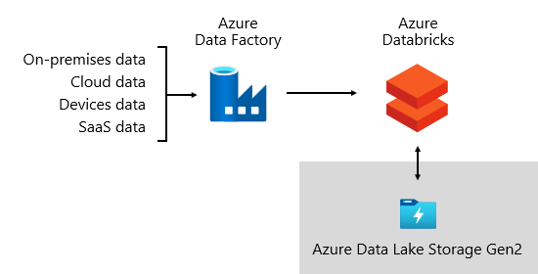

The architecture of analysis of online delivery apps typically involves a combination of data collection, processing, storage, and visualization components to gather insights from user interactions, transactions, and app performance metrics. The architecture can vary based on the specific requirements of the business and the tools and technologies used for analysis. Here is a high-level overview of the architecture commonly used in the analysis of online delivery apps:

1. Data Collection:

- User Interaction Data: Data related to user interactions with the app, such as clicks, views, searches, orders, and payments.

- App Performance Data: Metrics related to app performance, such as response time, errors, crashes, and latency.

- Marketing Data: Information on marketing campaigns, user acquisition channels, and conversion rates.

2. Data Ingestion:

- Real-time Data Streaming: Data from various sources is ingested in real-time using tools like Kafka, Amazon Kinesis, or Google Cloud Pub/Sub.

- Batch Processing: Historical data is processed in batches using tools like Apache Spark or Hadoop for deeper analysis.

3. Data Storage:

- Data Warehouses: Structured data is stored in data warehouses like Amazon Redshift, Google Big Query, or Snowflake for analysis and reporting.

- Data Lakes: Raw and unstructured data is stored in data lakes like Amazon S3 or Google Cloud Storage for further processing and exploration.

4. Data Processing:

- ETL (Extract, Transform, Load): Data is extracted from various sources, transformed into a usable format, and loaded into the data warehouse for analysis.

- Data Pipelines: Automated pipelines are set up to process and transform data for analysis using tools like Apache Airflow or AWS Glue.

5. Data Analysis:

- Business Intelligence Tools: Tools like Tableau, Power BI, or Looker are used to create dashboards, reports, and visualizations for business stakeholders.

- Advanced Analytics: Machine learning models and algorithms are applied for predictive analytics, user segmentation, and recommendation systems.

**CHAPTER 4**

**MODELING AND RESULT**

**Manage relationship**

The management of relationships in online delivery apps refers to how businesses interact and engage with their customers, delivery partners, and other stakeholders to build and maintain positive relationships. Effective relationship management is crucial for online delivery apps to enhance customer satisfaction, increase loyalty, and drive repeat business. Here are some key aspects of relationship management in online delivery apps:

1.Customer Relationship Management (CRM):

- Personalization: Online delivery apps use customer data to personalize the user experience, such as recommending favourite items, offering discounts based on purchase history, and sending targeted promotions.

- Communication: Apps communicate with customers through notifications, emails, and in-app messages to provide order updates, delivery status, and promotional offers.

- Feedback Collection: Apps collect feedback from customers through ratings, reviews, and surveys to understand their preferences, address issues, and improve service quality.

2. Delivery Partner Relationship Management:

- Onboarding: Online delivery apps onboard delivery partners by verifying their credentials, providing training on app usage and delivery processes, and setting expectations for service quality.

- Communication: Apps communicate with delivery partners regarding order assignments, pickup locations, delivery instructions, and payment details to ensure smooth operations.

- Incentives and Rewards: Apps offer incentives, bonuses, and rewards to motivate delivery partners, improve performance, and retain top performers.

3. Vendor Relationship Management:

- Partner Integration: Online delivery apps integrate with restaurant vendors, grocery stores, or other businesses to streamline order processing, inventory management, and payment reconciliation.

- Performance Monitoring: Apps monitor vendor performance in terms of order accuracy, on-time delivery, customer satisfaction, and compliance with service standards.

- Relationship Building: Apps collaborate with vendors to co-create promotional campaigns, launch exclusive deals, and explore new business opportunities for mutual benefit.

4. Brand Reputation Management:

- Social Media Engagement: Online delivery apps actively engage with customers on social media platforms to address queries, respond to feedback, showcase positive reviews, and promote brand awareness.

- Crisis Management: Apps have strategies in place to handle negative incidents or customer complaints promptly, resolve issues effectively, and protect the brand reputation.

- Community Building: Apps foster a sense of community among users by organizing events, contests, or loyalty programs that encourage engagement and brand advocacy.

5. Data Analytics and Insights:

- Customer Segmentation: Apps analyse customer data to segment users based on behaviour, preferences, demographics, and order history for targeted marketing campaigns and personalized experiences.

**Dashboard**

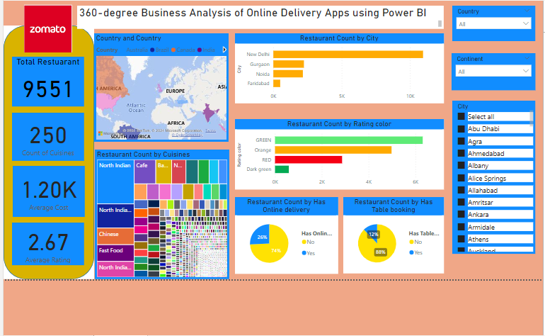

**References:**

<https://powerbi.pl/en/ms-power-bi/360-degree-analytics>

**Link:**

<https://github.com/kashika37/360-Degree-Business-Analysis-of-Online-Delivery-Apps-Using-Power-BI>